PRESS RELEASE
13 January 2021

Global Drone Inspection to take on specialist demand for drone and ROV services from RIMS BV

RIMS (Robotics in Maintenance Strategies) BV, an established class approved supplier of UAV inspections in the maritime industry have created Global Drone Inspection (GDI), to focus on the drone and ROV element of the business.

GDI will sit alongside RIMS, but with a different service portfolio offering. GDI will provide all the services around inspections of assets by drones and ROVs, including 3D modelling, while RIMS will continue to support clients with the development and integration of new technologies within their maintenance strategies.

David Knukkel, CEO, GDI & RIMS said: “With GDI, we aim to provide a centre of expertise in remote inspection technology which can be easily found by clients who need a specialist in this domain.
“GDI will build on the experience and success of RIMS which was set up in 2015. In last five years RIMS has brought the drone service to a professional level, and were the first maritime Class Approved service provider, supporting surveyors with the inspection of ship structures, mobile offshore units and confined spaces using Remote Inspection Technology, and it is our intention to replicate this level of success for GDI.”
GDI will be looking to strengthen its portfolio in line with future trends through partnership creation with well recognised partners and service suppliers, offering a total solution for inspections, NDT-measurements (non-destructive testing), presentation of information and repairs.

ENDS

Images
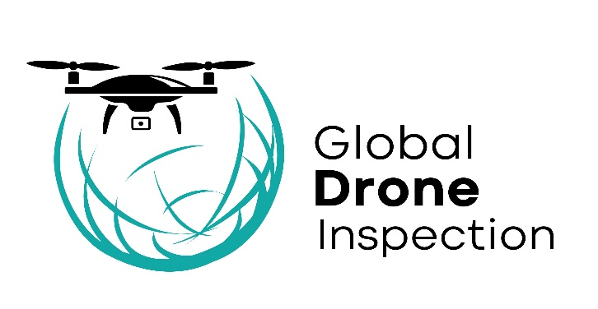
Image caption: Global Drone Inspection (GDI), new sister company of established maritime robotics in maintenance RIMS BV
Image caption: David Knukkel, CEO, GDI
Notes to editors:
About Global Drone Inspection (GDI)
Global Drone Inspection performs worldwide surveys on your assets with drone technology. Providing reliable information on maintenance required on assets to the shipping, oil, and gas, infra and steel industry.
For full details visit: www.drone-inspection.global
About RIMS

RIMS are a global project and maintenance consultancy to help revolutionise maintenance strategies with smart drones and robotic. RIMS’ high tech expertise in combination with smart asset management solutions mean customers benefit from much safer, more sustainable and cost-efficient surveying and maintenance solutions.

Further information can be found by visiting: www.rims-bv.com

Media Contact:  Kami Paulson  Head of Communications  Wake Media Ltd  t: +44 (0) 208 686 1728  e: kami.paulson@wake-media.co.uk | GDI Contact:  David Knukkel  CEO  t: +31 629 022 439  e: info@drone-inspection.global

